Margaret Mary Health Sponsorship Guidelines
Each year, Margaret Mary Health receives many requests for donations and sponsorship support. MMH is pleased to partner and support the community-based organizations that complement and impact the mission of our organization, which is “to improve the health of our communities.” While we recognize the contributions of these organizations to our communities, MMH is not able to support every request and for this reason, we have defined the following guidelines and criteria for consideration when submitting a request.
- Sponsorships must align with MMH’s mission, vision, values and strategic priorities.
- Sponsorships must benefit the primary communities served by MMH in Ripley and Franklin counties: Batesville, Oldenburg, Brookville, Metamora, Morris, Milan, Sunman, Osgood, Napoleon.
- The community organization and event/activity must seek to address a community health need and demonstrate a positive impact on the communities served.
- Sponsorship or program/event must reach and impact a substantial number of people in service area.
- The applicant/organization should be a non-profit 501(c)(3) organization in good standing. MMH does not support individual participation in a fundraising event or activity.
- Multiple sponsorships will not be extended to the same organization during a given year.
- MMH does not make financial donations to individuals or political candidates/campaigns.
Submitting your request:
- MMH reviews donation and sponsorship requests on an on-going basis; however, we request that you submit your application a minimum of 60 days prior to the event.
- All requests must be sent to the Marketing Department, Margaret Mary Health 321 Mitchell Avenue, Batesville, IN 47006 or can be emailed to info@mmhealth.org. Please include a completed sponsorship request form (link to document pdf) and any additional documents specific to the event, program or request. The request form can also be completed and submitted online here (link to web form).
- Please note all usage of the MMH logo and brand must be submitted for approval prior to production.
- Please be advised that we may not be able to fulfill every sponsorship request, even if the request meets our criteria.

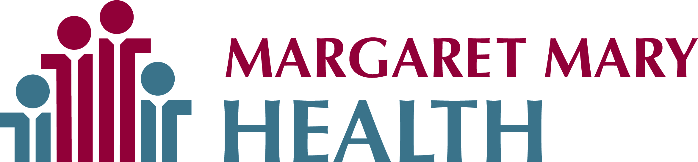
Sponsorship Request Form
Date of Request: ____________________________________________________________
Organizational Information
Organization: _______________________________________________________________
Contact Name: ______________________________ Title: ___________________________
Email: _____________________________________ Phone: _________________________
Mailing Address: _____________________________________________________________
Organization’s status (circle one): Non-profit For-profit Years in operations: _____
Have you received a sponsorship from Margaret Mary Health in the past? (circle one)
Yes No
If yes, please list amount(s), date(s) and a brief description of sponsorship and event/program.
__________________________________________________________________________
Event/Program Information
Name and description of sponsorship event: ______________________________________
Event Date: ____________ Location (city and facility): ______________________________
Expected Attendance (circle one):
1-100 100-300 300-500 500 – 1,000 1,000 – 2,000 2,000+
Requested sponsorship amount: ______________ Date needed: _____________________
How will Margaret Mary Health receive recognition as a sponsor?
_________________________________________________________________________
Deadline for deliverables: ____________________________________________________
Additional information you would like to provide: ___________________________________
_________________________________________________________________________
Please include/attach any supporting documentation about your event/program, promotional materials, etc.
Please note all usage of the Margaret Mary Health logo and brand must be submitted for approval prior to production.

Team Member Benefit and Fundraiser Guidelines

